Convert the entity relationship model to a relational diagram

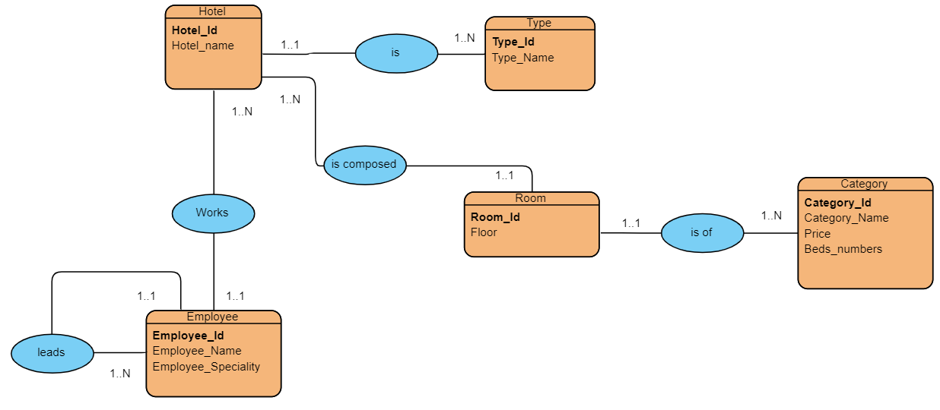Entity relationship model:

Relational diagram:

Hotel (**Hotel-Id**, Hotel_name, **#Type_Id**)

Type (**Type-Id**, Type_Name)

Employee (**Employee-Id**, Employee_Name, Employee_Speciality, **#Hotel_Id, #Director_Id**)

Director (**Director-Id)**

Room (**Room-Id**, Floor, **#Hotel_Id, #Category_Id**)

Category (**Category-Id**, Category_Name, Price, Beds_numbers)